ASIAN PARLIAMENTARY ASSEMBLY

APA Standing Committee meeting
on Political Affairs

25 - 28 June 2019
Isfahan, Islamic Republic of Iran

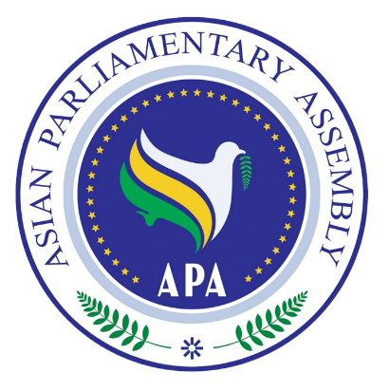
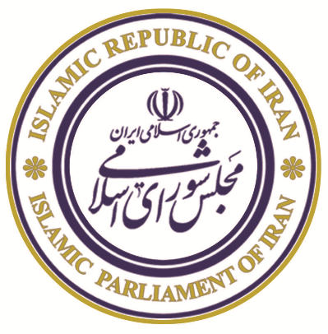
REGISTRATION FORM

REGISTRATION FORM

Please fill in one form for each participating delegate in CAPITAL letters, and return by 10 June 2019

DELEGATE DETAILS
Country: |  | Name of Parliament:
Salutation | ( ) Mr. ( ) Ms.
First Name
Last Name
Position | ( ) Head of Delegation ( ) Member of Parliament ( ) Officer
Tel. No.
Mobile No.
Fax No.
Email Address

PASSPORT DETAILS
Passport Type |  |  | ( ) Diplomatic ( ) Official ( ) Ordinary
Passport Number: |  |  |  |  |  | Date of birth :
Date of Issue: |  |  |  | Date of Expiry: |  | Place of Issue:

TRAVEL INFORMATION
Arrival |  |  | Departure
Date | Flight Number | Time | Date | Flight Number | Time

Kindly complete this form and send together with a scanned copy of the information page of the passport and 2″ x 2″ digital passport-sized photo, no later than 10 June 2019. Please forward
(e-mail) the completed form to both the Host Secretariat as well as CC to the APA Secretariat:

CC to APA Secretariat:

Email: secretariat@asianparliament.org
Phone: (+98-21) 33517406 - 7
Fax: (+98-21) 33517408
Host Secretariat:

Email: apairan2019@gmail.com
Phone: (+98-21) 33 440 322 - 3
Fax: (+98-21) 33 440 321
(+98-21) 33 52 39 79
+98 (0) 912 312 63 60

